**1- INTRODUCTION**

**INTRODUCTION**

**1.1 Project Overview:**

Developing a Rapid Food Order System to promote a greater count of food lovers to splurge into the field Restaurant. It integrates the benefits of an ordering food with the convenience of an online excitement and going with the technology, minus the commuting hazards and expenses. It will usher in the immense flexibility and sophistication in the existing manual platform structures, with the perfect blend of synchronous and asynchronous interaction. It provides a means of collaborative E-ordering for the customers.

The online application enables the end users to register online, select the food from the e-menu card, read the e-menu card and order food online. By just selecting the food that the user wants to have. The results after selecting the food from the E-menu card will directly in the screen near the Chef who is going to cook food for you. By using this application, the work of the waiter is reduced and we can also say that the work is nullified.

Nowadays people don’t have much time to spend in a restaurant by just there and waiting for the waiter to take their order. Many customer visits the restaurant in their lunch break and recess so they have limited time to eat ant return to their respective office and colleges. So this software helps them to save time and order food whenever they want without calling the waiter again and again.

**1.2 Existing System:**

The current of a company is very ancient and need to be replacing as companies business is expanding. One of the biggest disadvantages of the current system is that lacking of computerized food order each time a customer need to order food he has to wait for the wait to take their order and then give to the chef who will be preparing our food. So this process is very time consuming and very ancient. This is very difficult to manage. And there also situation where the customer mixes the order food of the one customer to another and there are also situations where customers forget to take the order taking the order he forgets to supply food on time.

All the existing system is traditional and lack of use of technology and lack of use of technology .therefore the process is very time consuming and lengthy as paper work is there. This was creating problem in maintain data record at the employee attendance. Bill etc.

This document will purpose all features and procedures to develop the system.

This document specially is very useful and important software, scope limitation, process model, primary requirement, and team development. Possible project risk, project schedule, and finally monitoring and reporting mechanisms.

Rapid food order System is very useful and important software for the Restaurant based Application .Its provide feature like online ordering. Directly connecting to the chef, employee attendance, payroll, salary slip, etc.

This software can also be used as reducing the man power used in the process. Depending on the computer which goes wrong and also provide us with the appropriate output. It is also reliable. As the word is going with the technology it important for us to also go with it. Using technology in the hotel makes the user attractive towards the restaurant.

**1.3 Proposed System:**

This online application enables the end users to register online. Select the food from e-menu card, read the E-menu card and order food online. By just selecting the food that the user want to have. The result after selecting the food from the E-menu card will directly appear in the screen near the chef who is going to cook the food for you. By using this application the work of the waiter is reduced and we can also say that the works nullified. The benefit of the is that if there is rush in the Restaurant then there will we be chances that the waiters will we be unavailable and the users can directly order the food to the chef online by using this application. The user will be given a username and a password, by sing that sometime a user logs in he/she gets 2% discount in the total bill. This implies that the customer is the regular user of the Restaurant.

Manual system involves paper work in the form of maintaining various files and manuals .Maintaining critical information in the files and manual is full of risk and a tedious process. Including a framework showing how to apply Internet technology progressively as skills and confidence grow. The project demonstrates the route from adapting materials to development an online environment.

Nowadays people don’t have much time to speed in restaurant by just and waiting for the take their order. Many customer visits the restaurant in their lunch break and recess so they have limited times to save time and order food whenever they want calling the waiter again. As well as if the customer is a regular customer of the Restaurant then the customer get 2% discount on every product they order.

The objective of this project is:

* To order food rapidly
* To make convenient for people who have limited time
* Cost reduction
* Reduced paper work
* Computerized order and billing system

**1.4 Scope of project:**

1. This project will help the hotels to store the data.
2. This project enables hotel manager to get information about staff and customers.
3. Project will enable to see report regarding food order.
4. Easy to maintain in future prospect.
5. The system reduces much of human efforts.

**2- FEASIBILTY STUDY**

**FEASIBILITY STUDY**

The basic idea behind feasibility study is to determine whether the project is feasible or not. Feasibility is conducted to identify a best system that meets all the requirements. This includes an identification, description, an evaluation of the proposed systems and selection of the best system for the job.

The requirements of the system are specified with a set of constraints such as system objectives and the description of the out puts. It is then duty of the analyst to evaluate the feasibility of the proposed system to generate the above results. Three key factors are to be considered during the feasibility study.

**2.1ProjectFeasibility:**

**1. Operation Feasibility**

An estimate should be made to determine how much effort and care will go into the developing of the system including the training to be given to the user. Usually, people are reluctant to changes that come in their progression. The computer initialization will certainly affected the turn over, transfer and employee job status. Hence an additional effort is to be made to train and educate the users on the new way of the system.

**2. Technical Feasibility**

The main consideration is to be given to the study of available resources of the organization where the software is to be implemented. Here the system analyst evaluates the technical merits of the system giving emphasis on the performance, reliability, maintainability and productivity.

By taking the consideration before developing the proposed system, the resources availability of the organization was studied. The organization was immense computer facilities equipped with sophisticated machines and the software hence this technically feasible.

**2.2Hardware Specification:**

1. Operating System:-Microsoft Windows 7/8/10
2. Processor: - Intel Pentium 4 or above.
3. Hard disk: - 80GB or above.
4. RAM:-512MB

**2.3Software Specification:**

1. Databases: SQL Server-2005/2017
2. Development Tool: MS Visual Studio 2010
3. Languages Used: C# and Asp.Net

.

**3- SYSTEM DESIGN**

**SYSTEM DESIGN**

**3.1 DFD (Data Flow Diagram):**

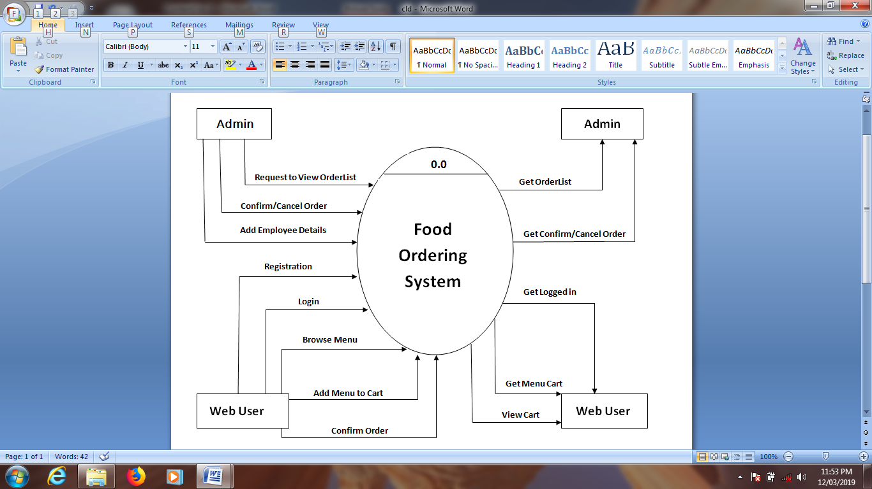

**1 level DFD:-**



**3.2 ERD (Entity Relationship Diagram):**

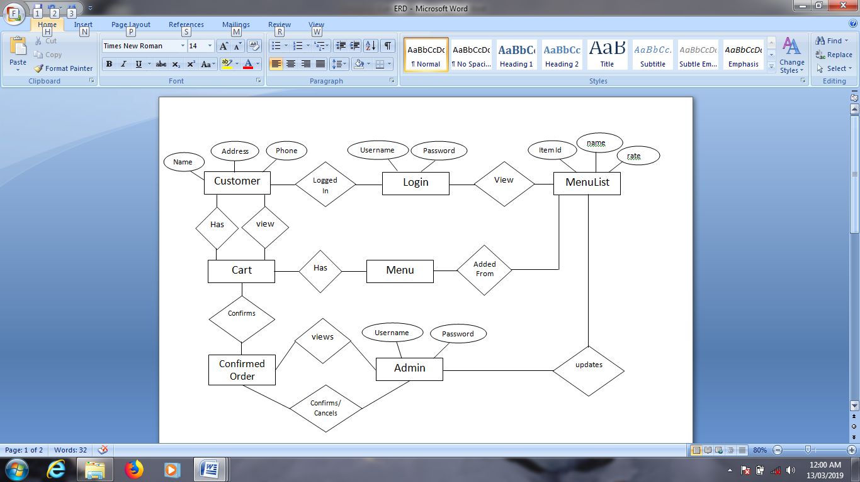

* 1. **Database Design:**

1. **Table Name: Admin Login**

|  |  |  |
| --- | --- | --- |
| **Field Name** | **Data Type** | **Constraints** |
| User name | Varchar (30) | Primary Key |
| Password | Varchar (30) | Not Null |

1. **Table Name: Registration**

|  |  |  |
| --- | --- | --- |
| **Field Name** | **Data Type** | **Constraints** |
| UserId | Numeric(18,0) | Primary Key |
| First name | Varchar(30) | Not Null |
| Lastname | Varchar(30) | Not Null |
| Address | Varchar(30) | Not Null |
| City | Varchar(30) | Not Null |
| Pincode | Numeric(18,0) | Not Null |
| Phoneno | Numeric(18,0) | Not Null |
| Emai­lId | Varchar(30) | Not Null |
| Password | Varchar(30) | Not Null |
| RoleId | Numeric(18,0) | Not Null |

**3. Table Name: User Login**

|  |  |  |
| --- | --- | --- |
| **Field Name** | **Data Type** | **Constraints** |
| EmailId | Varchar(50) | Primary Key |
| Password | Varchar(50) | Not Null |

**4. Table Name: Item Table**

|  |  |  |
| --- | --- | --- |
| **Field Name** | **Data Type** | **Constraints** |
| ItemId | Numeric(30) | Primary Key |
| ItemName | Varchar(30) | Not Null |
| ItemRate | Numeric(30) | Not Null |

**5. Table Name: Order Details**

|  |  |  |
| --- | --- | --- |
| **Field Name** | **Data Type** | **Constraints** |
| OrderId | Number(30) | Primary Key |
| Now_Date | Date | Not Null |
| Amount | Varchar(20,10) | Not Null |
| Quantity | Varchar(30) | Not Null |
| Item Name | Varchar(30) | Not Null |
| UserId | Numeric(18,0) | Not Null |
| Status | Varchar(20) | Not Null |

**6. Table Name: Employee Details**

|  |  |  |
| --- | --- | --- |
| **Field Name** | **Data Type** | **Constraints** |
| EmployeeId | Numeric(30) | Primary Key |
| EmpName | Varchar(50) | Not Null |
| EmpPhoneno | Numeric(30) | Not Null |
| EmpAddress | Varchar(50) | Not Null |

**4- IMPLEMENTATION**

**4.1 Output Screens:**

1. ***Homepage***

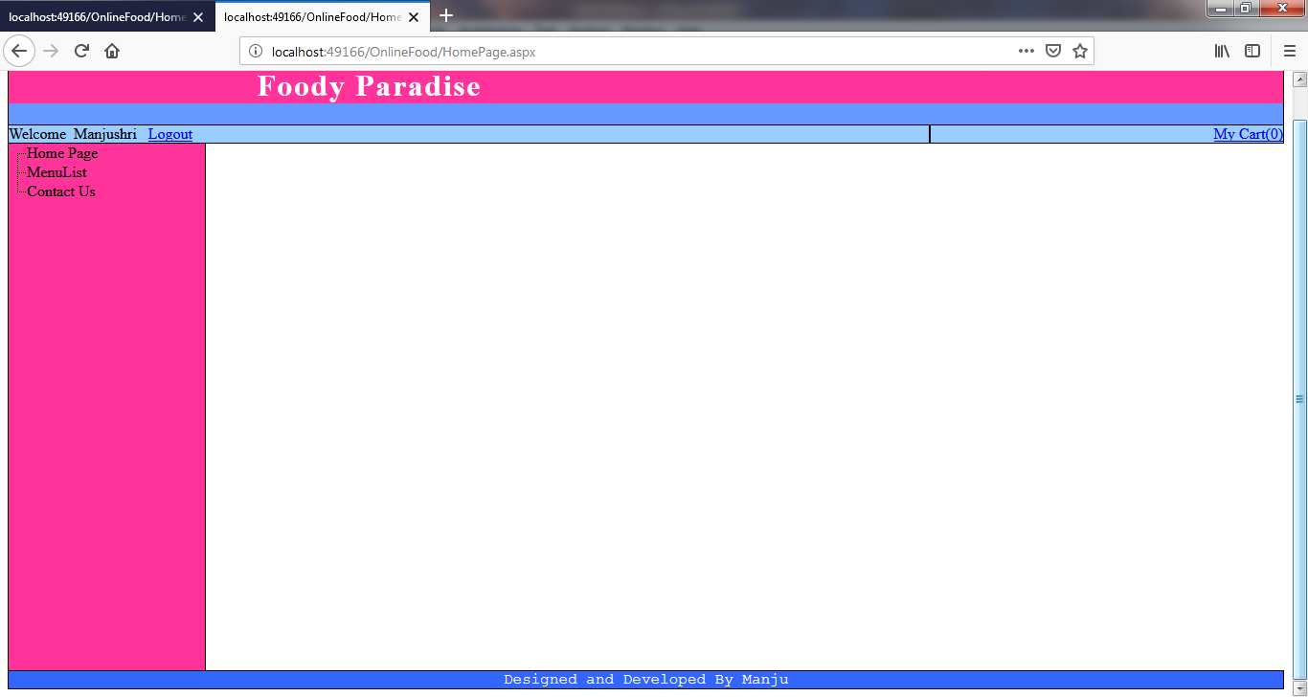

***User Views this HomePage*.**

1. ***Menu Page***

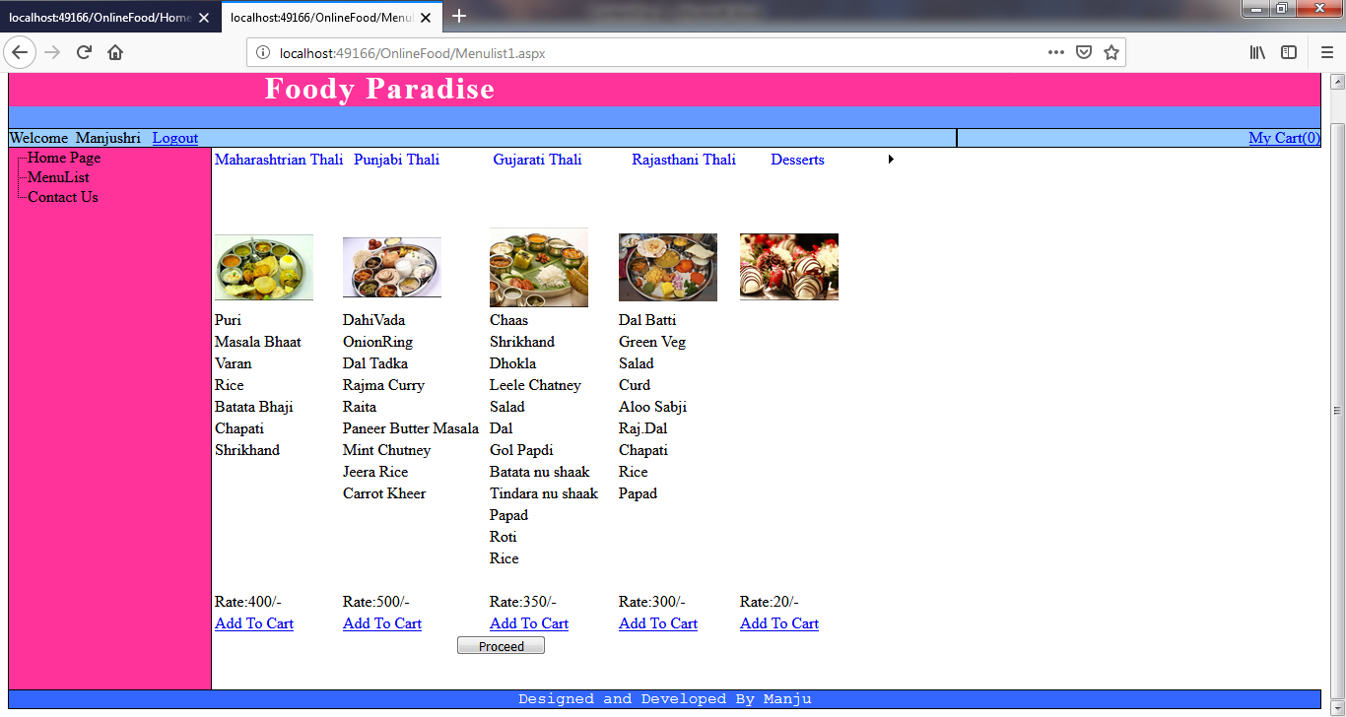

***User views menu list for ordering food***

**5-ADVANTAGES AND LIMITATIONS**

**ADVANTAGES AND LIMITATIONS**

**Advantages:**

• Managing and keeping record of all customers, bills and the entire system in digital format i.e. in computers.

• Waiters don’t have to manually keep a record of all food by the customer and that work is very easy.

• As it is online the customer doesn’t have to wait for the waiter to take order and doesn’t has to wait is very easy.

• Records are maintained in computers so that are less changes of damage and loss of data.

• Waiters don’t have to manually calculate the amount of money to be paid by the customer after having food it is automatically done in the software.

• More exposure for people in the word of technology.

• No telecommunication cost and no customer is missed.

**Limitations:**

•Change of Environment-If one person eats within home, he may not feel a change in environment around us. But comfort is really high in terms of online food take away.

•Delivery Time-Many restaurants will be open only for a few hours a day, and will be closed for the rest of the time.

**6-CONCLUSION**

**CONCLUSION**

• Overall we have created application in focus of future Food Ordering System, this application will be helpful to many people.

•This project was made user friendly by the use of visual basic enabling the user to interact easily with the database.

•The goal of the system is to solve the problem from previous system.

**7-BIBLIOGRAPHY**

**BIBLIOGRAPHY**

* [www.w3school.com](http://www.w3school.com)
* [www.projects.students3k.com](http://www.projects.students3k.com/)
* [www.studymode.com](http://www.studymode.com)
* And for collecting information and study the project details we visited the Surbhi Hotel for a survey.
* And we have referred the following books:
  + - The Complete Reference by Pratik Naughton and Herbert Schildt
    - The Programming language- Ivan Bayross